

The Store Is Yours
Trainer's guide to running a live session
A plain-English handbook for the facilitator running “The Store Is Yours”, the live retail leadership simulation set in Plumfield Stores. Read it once before your first session. Keep it beside you when you run one. Everything here matches the current build of the game.

1. What this is, in one breath
Each team runs a Plumfield store for eight shifts. Every shift they read what is happening on the floor and make a set of time-boxed leadership decisions on a shared laptop. Those decisions move live store numbers, and quietly move four hidden drivers underneath (trust, capability, safety risk and leadership consistency). It is head-to-head: several teams play the same shifts at the same time, and a leaderboard tracks them.
You are not a referee and you are not a lecturer. You open the room, brief them, start each shift, stay out of the way while they play, and then run the debrief where the real learning happens. The game hands you a tailored question for each team after every shift, so you always have somewhere to start.
The whole point is self-awareness. There are no right answers, only revealing ones. Say that early and mean it.
2. Before you start (kit and room)
You need:
- One screen for you, the facilitator. A laptop is fine, but a big screen or projector the whole room can see makes the briefing and debrief much stronger.
- One shared laptop per team. Teams gather round it and decide together. Sharing the laptop is deliberate; how they make decisions as a group is part of what you are watching.
- A steady internet connection for every device. The game is live and talks to a server the whole time. Weak wifi shows up as teams dropping and rejoining.
- Between two and eight teams. Four is the sweet spot. More teams means a busier debrief but a richer room.
A word on stability: the game saves each session to disk, so the data survives a server restart. If the server does restart mid-session (for example a redeploy), the game is not lost - but every laptop drops its live connection and has to reconnect (the facilitator reopens their link, teams refresh their page). That is disruptive in the moment even though nothing is lost, so it is still best to let Rapid Learn know when sessions are being ran to avoid deploying updates while a session is running.
3. Setting the game up
There are two roles, and each has its own screen. You are the Facilitator. The teams are Teams. They never share a screen with you.
To create the session (you):
- Open the game's web address The Store Is Yours · Plumfield Stores.
- You land on the splash screen. Press “Launch simulation”. The game goes full screen.
- Choose the Facilitator card on the left.
- Set the number of teams with the plus and minus buttons (two to eight) to keep debriefs on track time-wise, we recommend aiming for 2 to 3 teams per session. You can change your mind later by just starting with fewer; you do not have to wait for a full house.
- Press “Create session”. You are taken to your Facilitator dashboard, and a five-character session code appears top right (something like A7K2N).

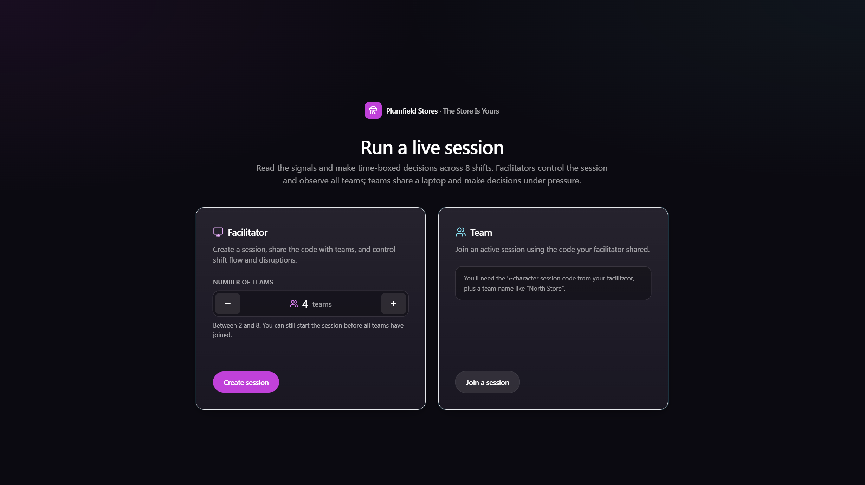
The landing screen: the Facilitator card on the left with the team-count stepper, and the Team card on the right.

Keep that dashboard open and do not lose the link. Your access is tied to a private token in that web address. If you close it, reopening from the same browser will usually get you back in; if you open a fresh browser with just the plain address, it will refuse you. Treat the session as yours alone.
To get the teams in (them):
- Each team opens the same web address on their laptop and presses “Launch simulation”.
- They choose the Team card on the right, then “Join a session”.
- They type your five-character code and a team name (for example “North Store”), and press “Join session”.
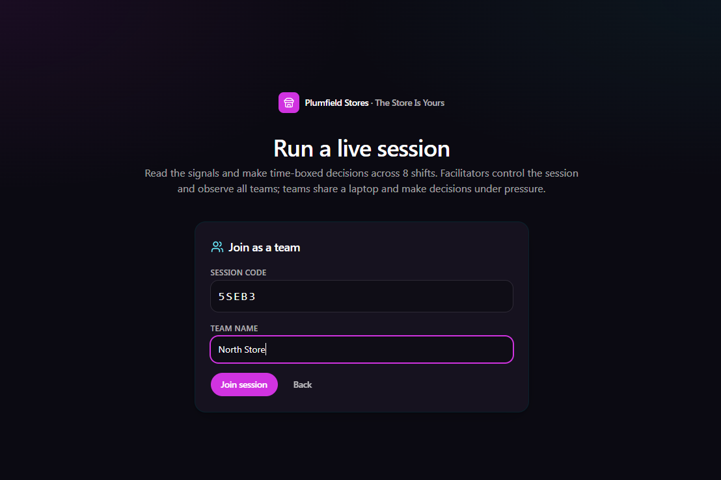
The team join screen: the code field and team-name field, before joining.

As each team joins, you see them appear on your dashboard in the lobby, filling the slots you set. When everyone is in, you are ready to brief. You can start before every slot is filled if a team is running late.
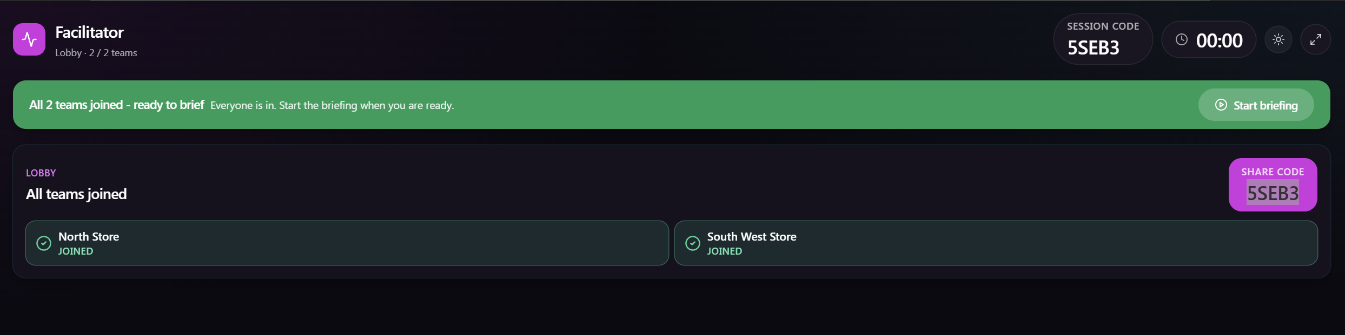
The facilitator lobby with teams appearing in their slots.

4. How a session runs, start to finish
The session moves through a fixed set of phases. You drive the moves between them. Only the shifts themselves are on a hard clock; everything else waits for you, so you can never be rushed through a briefing or a debrief.
Lobby | Teams join. You wait until you are ready.
Briefing | You walk the room through the screen, at your own pace.
Shift 1 | Twelve minutes on the clock. A longer opening shift so teams can settle in, look around the screen, try the inputs and read the handover before the pace picks up. Teams decide.
Debrief 1 | You debrief that shift. Takes as long as you let it.
Shift 2 ... | Eight minutes each from here on, for eight shifts in total.
Debrief 8 | The last shift debrief.
Full debrief | One reflective conversation across the whole session.
Close | You close the session and can download a report.

Rough timings: the first shift runs twelve minutes so teams can find their feet, try the controls and read the handover; every shift after it is eight minutes of play. A quick between-shift debrief is five to ten minutes. Budget a good three-quarters of an hour for the briefing plus that first shift, then settle into a rhythm. A full run of eight shifts with proper debriefs is a half-day workshop, not a lunch-hour filler. You control the pace throughout.
The one clock: the first shift lasts twelve minutes, each later shift eight. A shift ends when the timer hits zero, or sooner if every team has submitted. You can also end it early yourself.
5. How the game works (so you can explain it)
The store, in numbers. Every store is measured against five goals: Sales, Colleagues, Service, Costs and Risk. Underneath those five goals sit ten specific measures (things like sales against budget, availability, colleague engagement, customer satisfaction, labour and waste control, audits). The top-of-screen HUD shows the five goals at a glance; teams can open a full “All 10” view to see every measure with its real value against baseline and target. Each team also starts with sixteen weeks of history behind them, so even the first shift has a trend to read into.
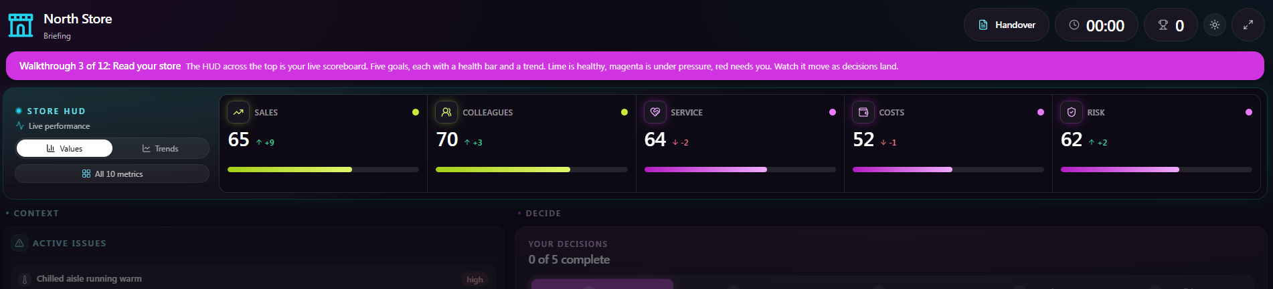
The metrics HUD across the top of the team screen: five goals with health bars and trends.

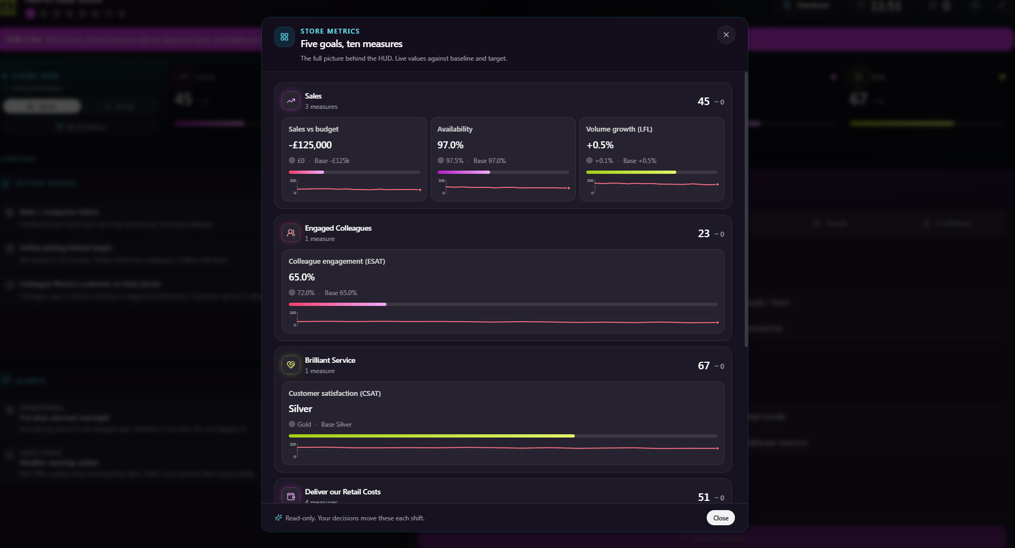
The “All 10” view: every measure with its real value against baseline and target.

The decisions. Each shift, a team makes seven decisions grouped into five tabs:
Focus | A priority to lead with, and how they will act on it. Both required.
Team | A leadership style, and how they split their people's time across four areas of the store (the split must add up to 100 percent). Both required.
Issue | How they spread their effort across the three live issues (sliders that must add up to 100 percent). Loading up on one sharpens the impact; sharing it out plays it broad. Required.
People | When a named member of their team needs them this shift, how they respond. Required whenever that person appears.
Confidence | How hard they back the whole plan: Cautious, Measured or Confident. Required.

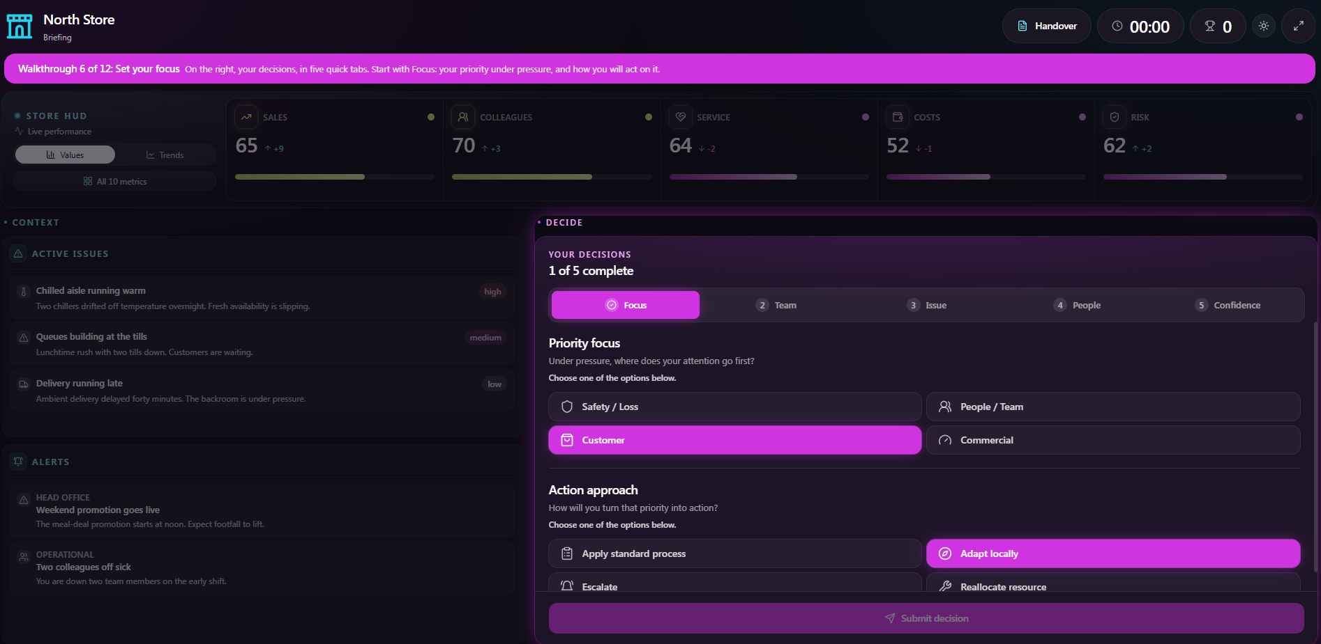
The decision panel on the right of the team screen, showing the five tabs.

Confidence is the sting. It multiplies everything that happens that shift, good and bad. Cautious dampens the swing (about three-quarters). Measured is straight. Confident amplifies it (about a third more either way). Backing a good plan hard pays off; backing a poor one hard hurts more.
The hidden drivers. Under the visible numbers sit four things the game never shows during a shift: trust, capability, safety risk and leadership consistency. They shape the score without appearing on the board. They are revealed after a shift resolves, on the team's own results screen and on your coaching cards. They are where a lot of the leadership learning lives.
What teams read before they act. On the left of their screen is Context: exactly three live Issues (what is happening in the store right now) and up to two Alerts from head office and operations. They should read these before deciding.
The handover, and why it lies. Every team can open a “Handover” document, a note from the outgoing manager, Ray Dolan. It is written to sound confident and helpful and it is deliberately unreliable. Ray tempts teams to act early on his word; teams who take him at face value make confident wrong moves, and teams who read him against what they actually see on the floor do better. You have a full answer key for this (see the debrief section). It is one of the richest threads in the whole game.
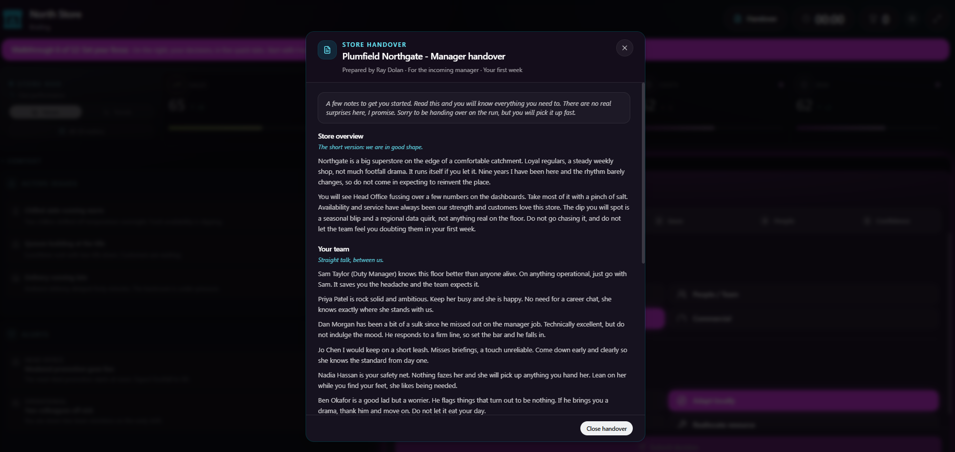
The Handover document opens over the screen - the note Ray Dolan left the incoming manager.

6. The random events, and the odds
The one source of genuine randomness you need to understand is disruptions. A disruption is something going wrong mid-shift: a fire alarm, a walkout, a till outage, a viral complaint, and so on.
The odds, plainly:
- Every shift has a fifty-fifty chance of a disruption. It is decided fresh each shift, so some shifts break and some stay completely clean.
- When one does fire, it lands somewhere in the first half of the shift (the first six minutes of the opening shift, the first four of a later one), at a moment nobody can predict.
- It hits every team at the same instant. That keeps it fair: no team gets an easier ride than another. It is the same store weather for everyone.
- You cannot trigger or cancel one. There is deliberately no “disrupt now” button. The unpredictability is the teaching point.
What that means across a full session of eight shifts: expect roughly four disruptions on average, but any given run can have more or fewer. It is possible, though very unlikely, to get a clean sweep or a run where nearly every shift breaks. Do not promise the room a disruption, and do not act surprised by a quiet shift; a shift with nothing going wrong tempts teams into their own revealing choices, which is useful in itself.
The other “events” are not random in the same way but are worth knowing:
- Issues: there are always exactly three live issues per shift.
- Alerts: up to two head-office or operational alerts, plus one more if a disruption is running, so never more than three messages at once.
- People moments: on some shifts a named direct report comes to the manager with a situation. When that happens, the People tab becomes required. How teams respond quietly moves trust and capability.
On your own screen, when a disruption is live during a shift, a clear “Disruption live” marker shows up in your control strip, so you always know the room is in the thick of one.
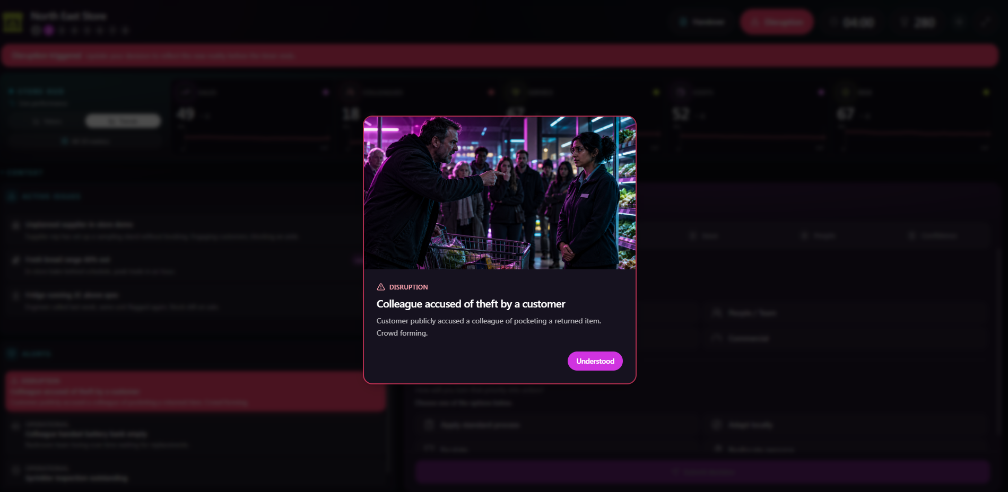
A disruption in play: the disruption banner on the team screen, and the “Disruption live” marker on the facilitator control strip.

7. Controlling the game (your dashboard)
Your Facilitator dashboard is built so the things you actually touch sit at the top, and the things you read sit below. From the top down:
- The header. Your session code (share this with latecomers), the shift clock, and how many teams are in. A full-screen toggle sits here too.
- The guidance banner. A short prompt telling you what this phase is for, with the single most important button on the right. That button always does the next big thing: “Start briefing”, then “Start Shift 1”, then “Start Shift 2” after each debrief, and finally “Begin debrief” and “Close session”. If you only remember one control, remember that this banner button moves you forward.
- The control strip. Directly beneath the banner. This is your moment-to-moment control and it changes with the phase. During the briefing it holds the Back and Next buttons that step the whole room through the walkthrough, with the step number and the current step's talking points. During a shift it holds “End shift early” and a live count of how many teams have submitted, plus the “Disruption live” marker when one is running. After the session it holds the “Download report” button. On the right of this strip you always see how many teams are in.
- The leaderboard. A compact ranking down the side, so you can see who is ahead and who is moving, without it dominating the screen.
- The coaching cards. The large area of the screen. One card per team. This is your debrief engine, described in the next section.
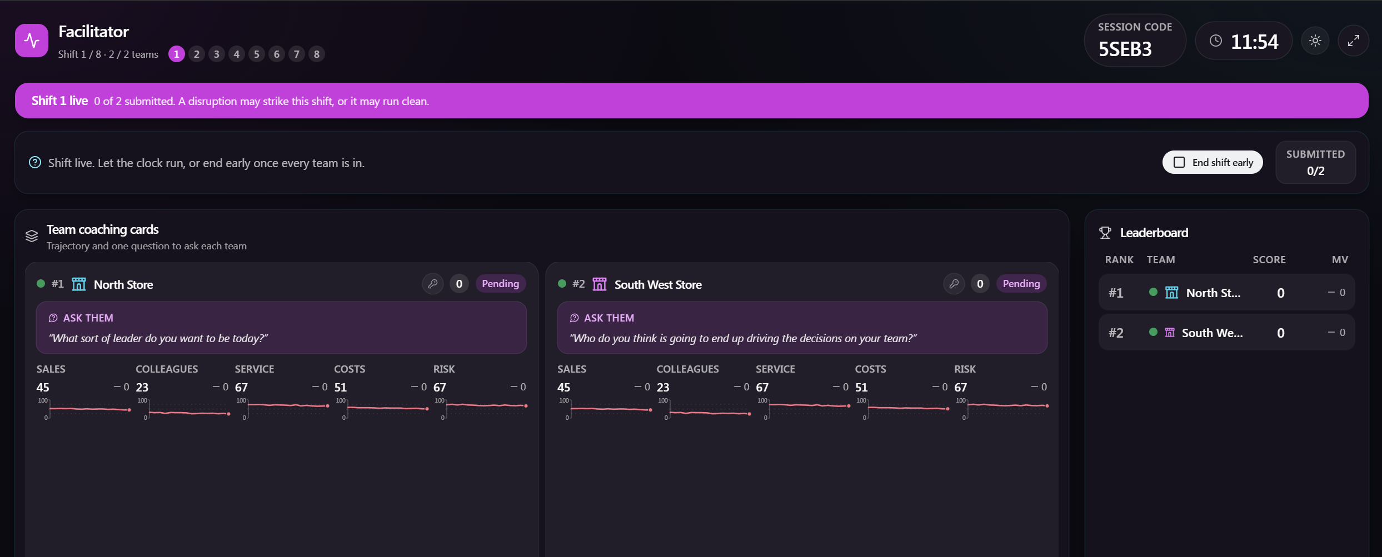
The full facilitator dashboard, annotated: header, guidance banner, control strip, leaderboard and coaching cards.

How a shift actually ends. It ends on its own when the clock runs out (twelve minutes on the opening shift, eight on each of the rest), or the moment all teams have submitted, whichever comes first. If the room is clearly done and you do not want to wait for the clock, press “End shift early”. After a shift ends you move into that shift's results, and the banner button becomes “Start Shift” for the next one when you are ready.
8. Running the briefing
The briefing is not a slide deck. It is a guided, animated tour of the real shift screen, and it happens on every team's laptop at once, in lockstep with you. You press Next; every team's screen advances to the same step and plays the matching little demonstration. You talk over it.
To run it: from the lobby, press “Start briefing” in the banner. Then use Back and Next in the control strip to move through the walkthrough. The strip shows you the step's title and a short talking script for each one, so you always know what to say. When you reach the end, press “Start Shift 1” in the banner.
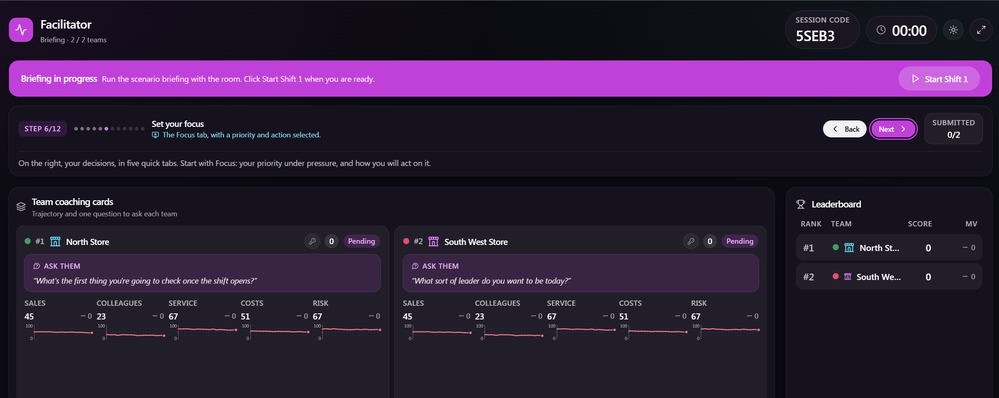
The briefing control strip on the facilitator screen: the Back/Next stepper with the step number and talking points.

There are twelve steps, and they lead the room through the screen in a natural order:
- 1. Welcome. The whole screen, at rest. Set the scene.
- 2. Read the handover. The handover document opens over the screen, so the room meets the note the outgoing manager left. Point out that it lives behind the Handover button in the header and is worth a read before the first shift.
- 3. Read your store. The top HUD lights up: five goals, health bars, trends.
- 4. See all ten measures. The full ten-metric view opens over the screen, so the room sees the real numbers behind the five goals. This is the moment to point out baselines and targets.
- 5. What's happening. The Context column: the three issues and the alerts.
- 6. Set your focus. The Focus tab: a priority and an action.
- 7. Lead your team. The Team tab: leadership style and the people split.
- 8. Spread your effort. The Issue tab: split your attention across the live issues, loading up on one or sharing it out.
- 9. Handle the people moment. The People tab: a real team member needs you.
- 10. Back your plan. The Confidence tab: cautious, measured or confident.
- 11. Expect the unexpected. A disruption strikes, to show what one looks like.
- 12. The store is yours. The full screen, bright and ready to play.
Keep it moving but do not rush. The briefing is where you set the tone: no right answers, decisions lock when the clock hits zero, and the numbers usually mean something even when the handover tells them otherwise. If your venue has the outgoing-manager welcome video, play it before you start the walkthrough; it points teams to the handover document.

9. Facilitating the shift debriefs (the prompt cards)
This is the heart of your job. After each shift, the game turns your dashboard into a set of prompt cards, one per team, and hands you tailored questions. You do not have to invent anything on the spot.
What is on each team's card:
- Who they are, their score and where they rank.
- Their five goals with the direction each one moved this shift.
- Once a shift has resolved, their hidden drivers (trust, capability, safety risk, leadership consistency), so you can see what was moving underneath.
- At the top of the card, an “Ask them” question. This is the important part. It is written for that specific team, anchored on the single measure that moved most for them this shift (or, if they held steady, the thing that barely moved). Two teams will get different questions even if they look similar, because the question follows their own story.
- A small key icon in the card's top corner. You will rarely need it: it generates a recovery link if a team ever has to move to a new device. See the troubleshooting section for how it works.
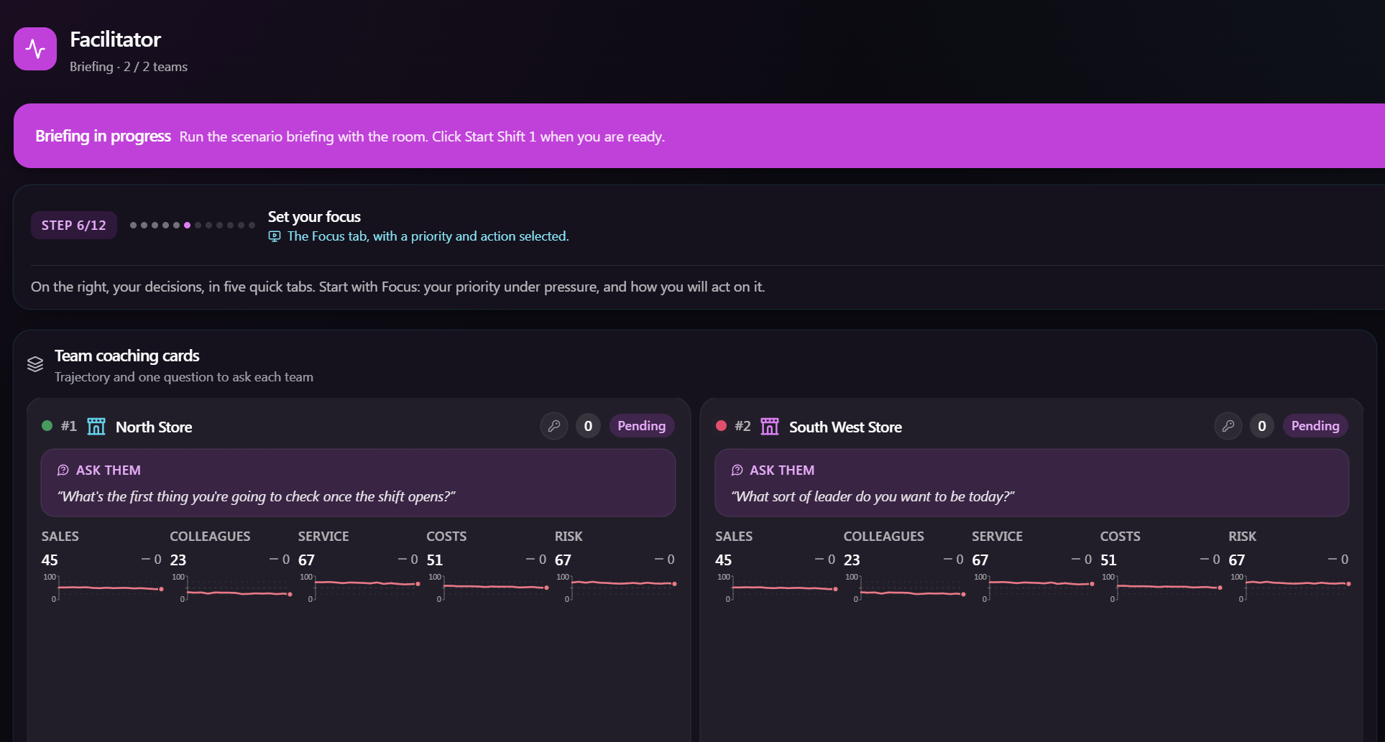
A team's coaching card: the “Ask them” question at the top, the five goals with their movement, the hidden drivers, and the key icon in the corner.

How to use the cards well:
- Lead with the card's question. Read the “Ask them” line to the team as it is, then stop talking. Sit in the silence. The second answer people give is usually the honest one.
- Follow up rather than move on. “Say more about that.” “What makes you say that?” A single question opened up beats six questions rattled through.
- Pick two or three teams, or two or three threads, per shift. You do not have to visit every card every shift. Spread the attention across the session.
- Do not read the score out as a verdict. The numbers are a way into the thinking, not the point of it. Resist ranking teams against each other out loud; surface the difference in approach instead.
- Watch who says “we” and who says “I”, and whether teams credit their choices or blame the game. Notice where the room goes quiet. That is usually where the learning is.
Your guidance banner also gives you a short, room-wide talk track for each shift, picking up on patterns it has spotted across all teams (for example, everyone chose the same priority, or the whole room played it cautious). Use those to open a whole-room conversation, then drop into individual cards.
Going deeper with the printed question bank. Alongside the on-screen questions you have a fuller bank of open questions, grouped by theme, in the file “debrief-questions.md”. Threads include priorities and focus, acting versus observing, leadership style, resource trade-offs, the people moment, confidence and risk, disruptions, reading the store versus trusting the gut, the handover, team dynamics, emotion and pressure, patterns over time, and transfer back to the real workplace. Keep it open on your own screen or printed beside you. Pick a couple that fit what you just watched. The same rule applies: two or three, not ten, then sit in the silence.
The handover thread (the unreliable narrator). One of the strongest debrief seams is Ray Dolan's handover. You have a full answer key in “handover-facilitator-crib.md”: it lists, person by person and claim by claim, where Ray steers teams wrong and what the floor actually shows. Do not pre-empt it; let teams discover the mismatches themselves across the shifts. Then in the debrief, ask the open handover questions first (“How much did you trust the handover?”, “Where did what you found differ from what you were told?”), and only then, where it sharpens the point, name a specific trap from the crib. Frame it as a leadership lesson in reading people and data for yourself, never as a gotcha. Ray's sign-off, “trust your gut over the dashboards”, is the whole mechanic in one line; it is worth quoting back to the room and asking whose gut they trusted, his or their own, and what it cost or saved them.
10. The full-session debrief
After the eighth shift, the banner offers “Begin debrief”. This is the one reflective conversation that looks across the whole session rather than a single shift. Your dashboard gives you a set of wide-angle questions for it, for example:
- Looking across all eight shifts, what pattern do you see in your own decisions?
- Where did your leadership instincts serve you well, and where did they let you down?
- What did the hidden drivers reveal about how you were actually leading?
- Which shift felt the most different to manage, and why?
- What is one thing you will try differently on Monday morning?
Let this run. This is where individual shift moments join up into a leadership signature people can actually take away. Watch for genuine reflection versus polished defending, and again, mind the quiet.
11. Closing and the report
When the conversation is done, press “Close session”. You can then use “Download report” in the control strip to open a clean, printable session summary you can share with the room or keep for your records. Leave the final leaderboard up for half a minute while people settle, thank the room, and point them to any follow-up material.
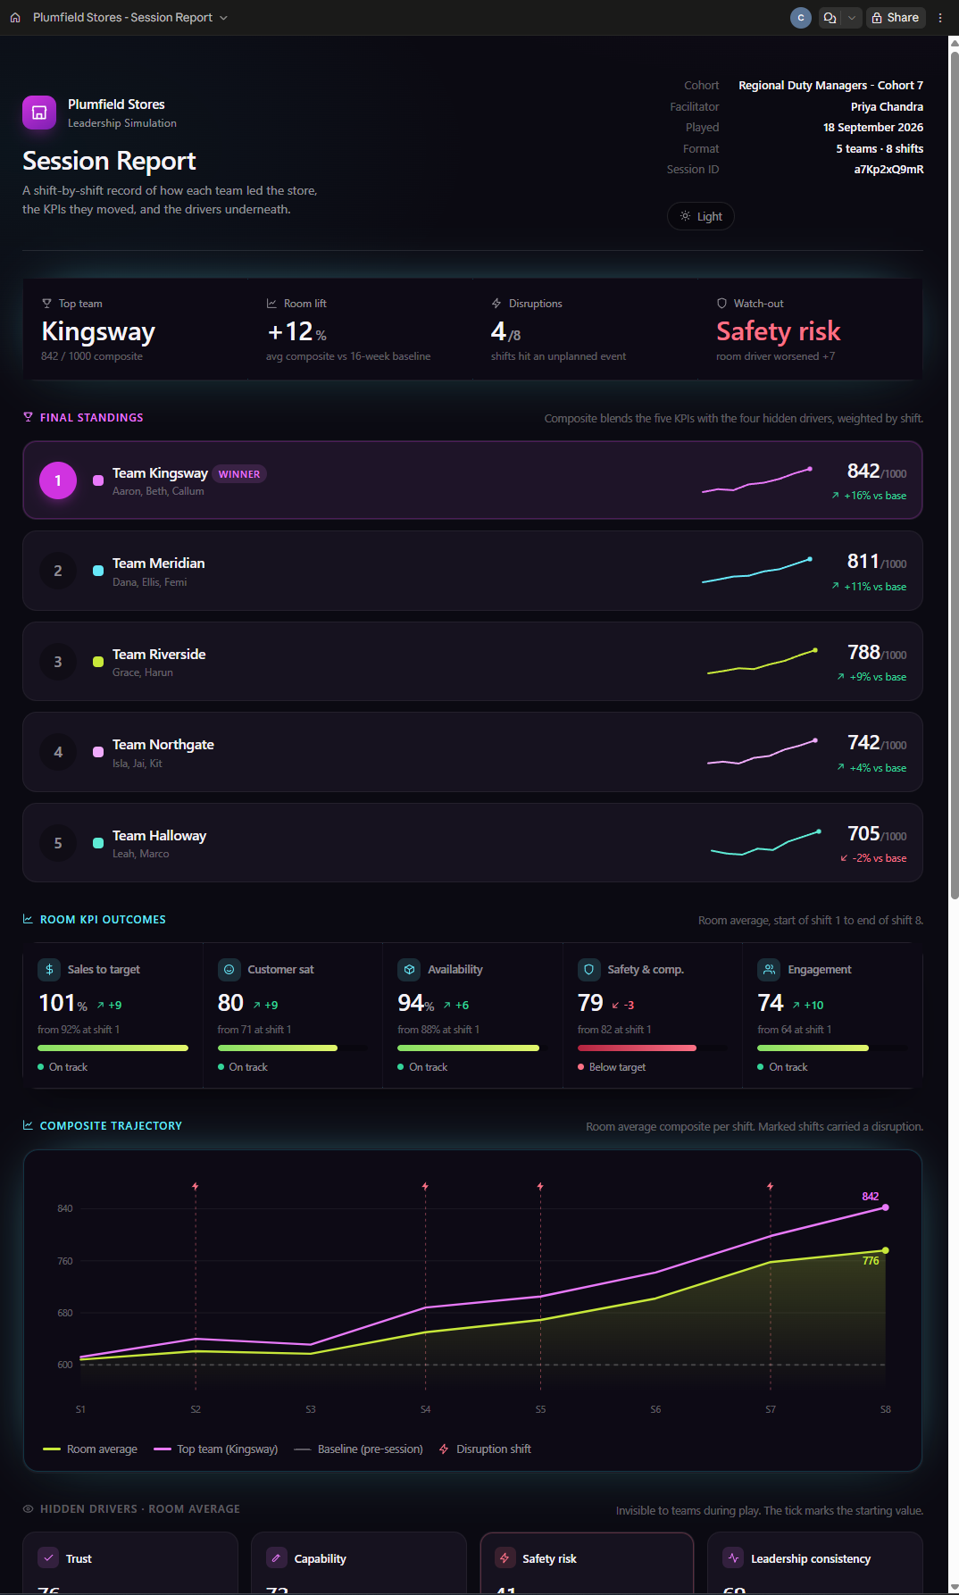
The downloadable session report: the printable summary produced at close.

12. When things wobble (troubleshooting)
- A team's laptop drops out. The game reconnects automatically when the wifi recovers, and they rejoin the same team without losing their place. If it hangs, they can refresh the page, or even close the tab and reopen the game on that same laptop - their team is remembered on that machine, so a refresh or accidental close no longer loses their place.
- A team has to move to a different device (their laptop died, or someone cleared the browser). Use the recovery link. On your dashboard, each team's coaching card has a small key icon in its top corner. Click it and you get a one-off recovery link for that team; copy it and send it to the team however is easiest (paste it into their new device's browser, or share it over chat). Opening the link puts them back into their own team with their score and history intact. There are no codes to read out. Note that issuing a new link retires the old one, so use it when a team has genuinely lost their original device, not while they are still on it.
- You lose your dashboard. Reopen it in the same browser you created it in and it should let you straight back in. This is why you keep that tab open and do not hand your link around.
- A team cannot join. Check they are typing the exact five-character code, in capitals, and that the session is still open. Codes are case-insensitive on entry but must match.
- Everything freezes and nobody can act for a minute. The server may be restarting (for example a redeploy). The session data is saved to disk and comes back, but everyone has to reconnect: you reopen your dashboard link, teams refresh their page. Give it a minute, then reconnect. This is why it is still best not to deploy or restart anything during a live run.
- Do not point security scanners at the live site during a session. If you are doing any technical testing, that is a separate, offline exercise.

13. Quick reference
Teams per session | 2 to 8 (4 is ideal)
Session code | 5 characters, you share it
Shifts | 8
Shift length | 12 minutes for Shift 1, then 8 minutes each (ends early if all teams submit)
Briefing | 12 guided steps, you set the pace
Disruption chance | 50 percent per shift, independent each shift
Disruption timing | somewhere in the first half of the shift
Disruption fairness | same moment for every team; you cannot trigger it
Expected disruptions | about 4 across a full session, but it varies
Live issues | always 3 per shift
Alerts | up to 2, plus 1 more during a disruption
Decisions | 7 inputs across 5 tabs
Confidence | Cautious ~0.75, Measured 1.00, Confident ~1.35
Hidden drivers | trust, capability, safety risk, leadership consistency
Baseline history | 16 weeks per team

Your two companion documents:
- Facilitation Prompt Cards - the full open-question bank, grouped by theme.
- Handover Facilitator Crib Sheet - the answer key to Ray's unreliable handover.

Run it warm, keep out of the shifts, and do your best work in the debriefs. The game will always hand you a way in.

